**Batch: C3-1 Roll No.: 16010122221**

**Experiment / assignment / tutorial No.**

**Grade: AA / AB / BB / BC / CC / CD /DD**

**Signature of the Staff In-charge with date**

|  |
| --- |
| **TITLE:**  Inheritance, Polymorphism and Abstract Class in Python |

**AIM: 1.** Write a program to implement inheritance to display information of bank account.

**2.** Write a program to implement polymorphism to display vehicle information

**______________________________________________________________________**

**Expected OUTCOME of Experiment:**

CO1: Use basic data structures in Python

CO2: Use different Decision Making statements and Functions in Python.

CO3: Apply Object oriented programming concepts in Python

**Resource Needed: Python IDE**

**______________________________________________________________________**

**Theory:**

**Inheritance:**

Inheritance is the capability of one class to derive or inherit the properties from some another class. The benefits of inheritance are:

1. It represents real-world relationships well.

2. It provides reusability of a code. We don’t have to write the same code again and again. Also, it allows us to add more features to a class without modifying it.

3. It is transitive in nature, which means that if class B inherits from another class A, then all the subclasses of B would automatically inherit from class A.

**Syntax:**

class Person(object):

    # Constructor

    def __init__(self, name):

        self.name = name

    # Inherited or Sub class (Note Person in bracket)

class Employee(Person):

    # Here we return true

    def isEmployee(self):

        return True

**Different forms of Inheritance:**

**1. Single inheritance**: When a child class inherits from only one parent class, it is called as single inheritance. We saw an example above.

**2. Multiple inheritance**: When a child class inherits from multiple parent classes, it is called as multiple inheritance.

class Base1(object):

 . . . .

class Base2(object):

. . . .

class Derived(Base1, Base2):

. . . .

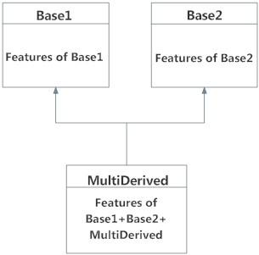Multiple Inheritance in Python

3. **Multilevel inheritance**: When we have child and grand child relationship.

class Person(object):

. . .

# Inherited or Sub class (Note Person in bracket)

class Child(Base):

. . .

# Inherited or Sub class (Note Child in bracket)

class GrandChild(Child):

. . . .

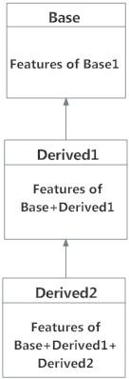

Multilevel Inheritance

**Private members of parent class:**

Python doesn't have any mechanism that effectively restricts access to any instance variable or method. Python prescribes a convention of prefixing the name of the variable/method with single or double underscore to emulate the behaviour of protected and private access specifiers.

We don’t always want the instance variables of the parent class to be inherited by the child class i.e. we can make some of the instance variables of the parent class private, which won’t be available to the child class.

All members in a Python class are public by default. Any member can be accessed from outside the class environment.

Example: Public Attributes

**class employee:**

**def __init__(self, name, sal):**

**self.name=name**

**self.salary=sal**

**e1= employee(1000)**

**print(e1.salary)**

Python's convention to make an instance variable protected is to add a prefix _ (single underscore) to it. This effectively prevents it to be accessed, unless it is from within a sub-class. This doesn't prevent instance variables from accessing or modifying the instance

Example: Protected Attributes

**class employee:**

**def __init__(self, name, sal):**

**self._name=name # protected attribute**

**self._salary=sal # protected attribute**

A double underscore __ prefixed to a variable makes it private. It gives a strong suggestion not to touch it from outside the class. Any attempt to do so will result in an AttributeError:

Example: Private Attributes

**class employee:**

**def __init__(self, name, sal):**

**self.__name=name # private attribute**

**self.__salary=sal # private attribute**

Python performs name mangling of private variables. Every member with double underscore will be changed to _object._class__variable. If so required, it can still be accessed from outside the class, but the practice should be refrained.

**e1=Employee("Bill",10000)**

**print(e1._Employee__salary)**

**e1._Employee__salary=20000**

**print(e1._Employee__salary)**

**super() method and method resolution order(MRO)**

In Python, super() built-in has two major use cases:

Allows us to avoid using base class explicitly

Working with Multiple Inheritance

**super() with Single Inheritance:**

In case of single inheritance, it allows us to refer base class by super().

class Mammal(object):

def __init__(self, mammalName):

print(mammalName, 'is a warm-blooded animal.')

class Dog(Mammal):

def __init__(self):

print('Dog has four legs.')

**super().__init__('Dog') # instead of Mammal.__init__(self, 'Dog')**

**d1 = Dog()**

The super() builtin returns a proxy object, a substitute object that has ability to call method of the base class via delegation. This is called indirection (ability to reference base object with super())

Since the indirection is computed at the runtime, we can use point to different base class at different time (if we need to).

**Polymorphism:**

Polymorphism is taken from the Greek words Poly (many) and morphism (forms). It means that the same function name can be used for different types. This makes programming more intuitive and easier.

**Polymorphism in Python:**

A child class inherits all the methods from the parent class. However, in some situations, the method inherited from the parent class doesn’t quite fit into the child class. In such cases, you will have to re-implement method in the child class.

There are different methods to use polymorphism in Python. You can use different function, class methods or objects to define polymorphism.

**Polymorphism with Function and Objects:**

You can create a function that can take any object, allowing for polymorphism.

**Example:**

Create a function called “func()” which will take an object which we will name “obj”. and let give the function something to do that uses the ‘obj’ object which is passed to it. Now, call the methods type() and color(), each of which is defined in the two classes ‘Tomato’ and ‘Apple’ by creating instances of both the ‘Tomato’ and ‘Apple’ classes if they do not exist:

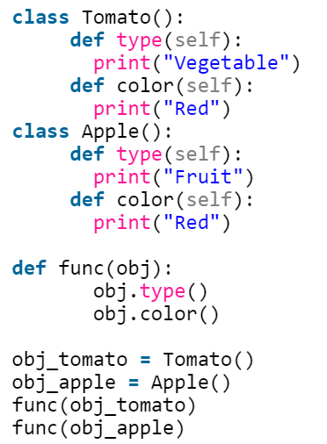 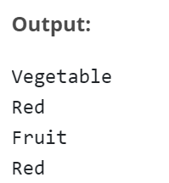

**Polymorphism with Class Methods:**

Python uses two different class types in the same way. Here, you have to create a for loop that iterates through a tuple of objects. Next, you have to call the methods without being concerned about which class type each object is. We assume that these methods actually exist in each class

**Example:**

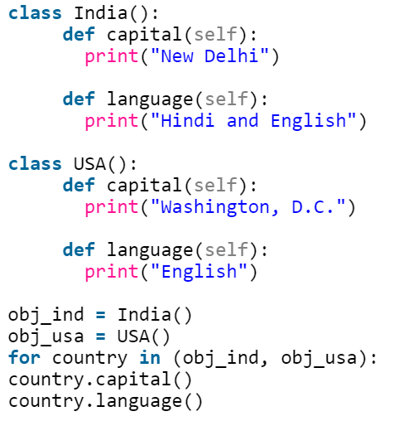 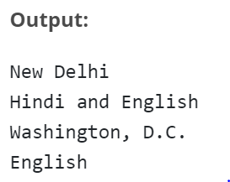

**Polymorphism with Inheritance:**

Polymorphism in python defines methods in the child class that have the same name as the methods in the parent class. In inheritance, the child class inherits the methods from the parent class. Also, it is possible to modify a method in a child class that it has inherited from the parent class.

This is mostly used in cases where the method inherited from the parent class doesn’t fit the child class. This process of re-implementing a method in the child class is known as Method Overriding.

**Example:**

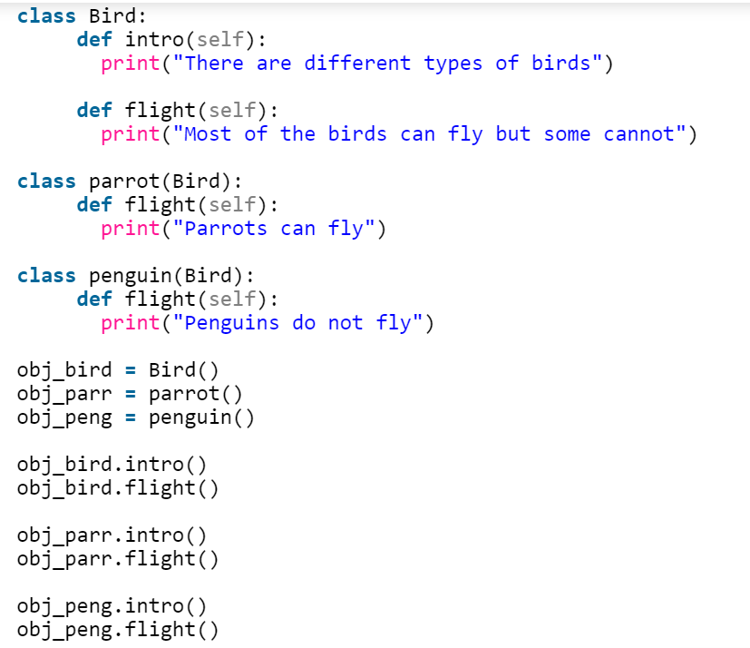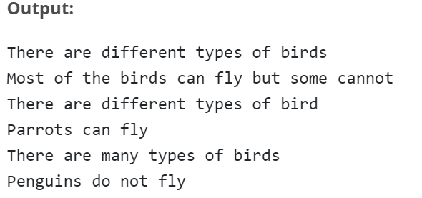

**Abstract Class:**

Abstract Class is concept of object-oriented programming based on DRY (Don’t Repeat Yourself) principle. In a large project, code duplication is approximately equal to bug reuse and one developer is impossible to remember all classes’ details. Therefore, it’s very helpful to use an abstract class to define a common interface for different implementations.

An abstract class has some features, as follows:-

* An abstract class doesn’t contain all of the method implementations required to work completely, which means it contains one or more abstract methods. An abstract method is a method that just has a declaration but does not have a detail implementation.
* An abstract class cannot be instantiated. It just provides an interface for subclasses to avoid code duplication. It makes no sense to instantiate an abstract class.
* A derived subclass must implement the abstract methods to create a concrete class that fits the interface defined by the abstract class. Therefore it cannot be instantiated unless all of its abstract methods are overridden.

**Define Abstract Class in Python:**

Python comes with a module called abc which provides methods for abstract class.

Define a class as an abstract class by abc.ABC and define a method as an abstract method by abc.abstractmethod. ABC is the abbreviation of abstract base class.

**Example:**

from abc import ABC, abstractmethod

class Animal(ABC):

@abstractmethod

def move(self):

pass

a = Animal() # TypeError: Can't instantiate abstract class Animal with abstract methods move

class Animal():

@abstractmethod

def move(self):

pass

a = Animal() # No errors

**Invoke Methods from Abstract Classes:**

An abstract method is not needed to be “totally abstract” in Python. We can define some content in an abstract method and use super() to invoke it in subclasses.

**Example:**

from abc import ABC, abstractmethod

class Animal(ABC):

@abstractmethod

def move(self):

print('Animal moves')

class Cat(Animal):

def move(self):

super().move()

print('Cat moves')

c = Cat()

c.move()

**Output:**

Animal moves

Cat moves

**Problem Definition:**

1. For given program find output

|  |  |  |
| --- | --- | --- |
| Sr.No | Program | Output |
| 1 | class Rectangle:  def __init__(self, length, width):  self.length = length  self.width = width  def area(self):  return self.length * self.width  def perimeter(self):  return 2 * self.length + 2 * self.width  class Square(Rectangle):  def __init__(self, length):  super().__init__(length, length)  square = Square(4)  print(square.area()) | 16 |
| 2 | class Person:  def __init__(self, fname, lname):  self.firstname = fname  self.lastname = lname  def printname(self):  print(self.firstname, self.lastname)  class Student(Person):  def __init__(self, fname, lname, year):  super().__init__(fname, lname)  self.graduationyear = year  x = Student("Wilbert", "Galitz", 2018)  print(x.graduationyear) | 2018 |
| 3 | class Bank:  def getroi(self):  return 10  class SBI:  def getroi(self):  return 7    class ICICI:  def getroi(self):  return 8  b1=Bank()  b2=SBI()  b3=ICICI()  print("Bank rate of interest:",b1.getroi())  print("SBI rate of interest:",b2.getroi())  print("ICICI rate of interest:",b3.getroi()) | Bank rate of interest: 10  SBI rate of interest: 7  ICICI rate of interest: 8 |

1. Create a class account that stores customer name, account number and type of account. From this derive the classes cur_acct and sav_acct to make them more specific to their requirements. Include necessary member functions in order to achieve the following tasks:

* Accept deposit from a customer and update the balance.
* Display the balance.
* Compute and deposit interest.
* Permit withdrawal and update the balance.
* Check for the minimum balance, impose penalty, necessary and update the balance.

1. Write a program that defines an abstract class called Vehicle containing an abstract method speed (). Derive from it two classes - FourWheeler and TwoWheeler. Create objects of derived classes and call the speed () method using these objects, passing to it the name of vehicle and speed of vehicle. In the speed () method print the vehicle name and the speed of vehicle to which speed () belongs.

**Books/ Journals/ Websites referred:**

* 1. **Reema Thareja , “Python Programming: Using Problem Solving Approach”, Oxford University Press, First Edition 2017, India**
  2. **Sheetal Taneja and Naveen Kumar,” Python Programing: A Modular Approach”, Pearson India, Second Edition 2018, India**
  3. <https://www.programiz.com/python-programming/methods/built-in/super>
  4. <https://www.tutorialsteacher.com/python/private-and-protected-access-modifiers-in-python>
  5. <https://www.geeksforgeeks.org/inheritance-in-python/>

**Implementation details:**

**2.**

class Account:

def __init__(self, name, account_number, account_type):

self.name = name

self.account_number = account_number

self.account_type = account_type

self.balance = 0

def deposit(self, amount):

self.balance += amount

def display_balance(self):

print(f"Balance for account {self.account_number} ({self.name}): {self.balance}")

def compute_interest(self):

# This method should be overridden by subclasses that have interest rates

pass

def withdraw(self, amount):

if amount > self.balance:

print("Insufficient funds")

else:

self.balance -= amount

print(f"Withdrawal of {amount} from account {self.account_number} ({self.name}) successful")

def check_minimum_balance(self, minimum_balance, penalty):

if self.balance < minimum_balance:

print(f"Balance below minimum ({minimum_balance}), applying penalty of {penalty}")

self.balance -= penalty

class CurrentAccount(Account):

def __init__(self, name, account_number):

super().__init__(name, account_number, "Current")

self.interest_rate = 0.0

def withdraw(self, amount):

if amount > self.balance:

print("Insufficient funds")

elif amount > 10000:

print("Maximum withdrawal from current account is 10000")

else:

self.balance -= amount

print(f"Withdrawal of {amount} from account {self.account_number} ({self.name}) successful")

def compute_interest(self):

# Current accounts don't have interest

pass

class SavingsAccount(Account):

def __init__(self, name, account_number):

super().__init__(name, account_number, "Savings")

self.interest_rate = 0.05

def compute_interest(self):

interest = self.balance * self.interest_rate

self.deposit(interest)

print(f"Interest of {interest} credited to account {self.account_number} ({self.name})")

# Create some accounts

current_account = CurrentAccount("John Doe", "12345")

savings_account = SavingsAccount("Jane Smith", "67890")

# Make some transactions

current_account.deposit(50000)

savings_account.deposit(100000)

current_account.display_balance()

savings_account.display_balance()

savings_account.compute_interest()

current_account.withdraw(20000)

savings_account.withdraw(50000)

current_account.check_minimum_balance(10000, 500)

savings_account.check_minimum_balance(10000, 500)

current_account.display_balance()

savings_account.display_balance()

**3.**

from abc import ABC, abstractmethod

class Vehicle(ABC):

@abstractmethod

def speed(self, name, speed):

pass

class FourWheeler(Vehicle):

def speed(self, name, speed):

print(f"{name} has a speed of {speed} km/h and it is a four-wheeler.")

class TwoWheeler(Vehicle):

def speed(self, name, speed):

print(f"{name} has a speed of {speed} km/h and it is a two-wheeler.")

# Creating objects of derived classes and calling speed() method

vehicle1 = FourWheeler()

vehicle1.speed("Car", 100)

vehicle2 = TwoWheeler()

vehicle2.speed("Bike", 80)

**Output(s):**

2.

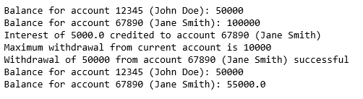

3.



**Conclusion:**

We got to learn about the Inheritance, Polymorphism and Abstract Class in Python.

**Post Lab Questions:**

1. Explain *isinstance()* and *issubclass()* functions with example

isinstance() and issubclass() are two built-in functions in Python that help in checking the inheritance relationship between classes and objects.

* isinstance() function returns True if the specified object is an instance of the specified class, or of a subclass thereof; otherwise it returns False.
* issubclass() function returns True if the specified class is a subclass of the specified class or a subclass thereof; otherwise it returns False.

Here are some examples to illustrate the usage of these functions:

**isinstance() :**

class Vehicle:

pass

class Car(Vehicle):

pass

car = Car()

print(isinstance(car, Car)) # Output: True

print(isinstance(car, Vehicle)) # Output: True

print(isinstance(car, object)) # Output: True

print(isinstance(5, int)) # Output: True

**issubclass():**

class Vehicle:

pass

class Car(Vehicle):

pass

class Motorcycle(Vehicle):

pass

print(issubclass(Car, Vehicle)) # Output: True

print(issubclass(Motorcycle, Vehicle)) # Output: True

print(issubclass(Car, Motorcycle)) # Output: False

print(issubclass(int, object)) # Output: True

1. Explain difference between inheritance and abstract class with example

Inheritance and abstract classes are two important concepts in object-oriented programming. Both concepts provide a way to define a hierarchy of related classes, but they differ in their purpose and implementation.

Inheritance is a mechanism by which one class can inherit the properties and behaviors of another class. The class that is being inherited from is called the base class or parent class, and the class that inherits from it is called the derived class or child class. The derived class can override the methods and properties of the parent class, or it can add its own methods and properties. Inheritance provides a way to reuse code and to create more specialized classes based on a common base.

Here is an example of inheritance in Python:

class Animal:

def __init__(self, name):

self.name = name

def speak(self):

pass

class Dog(Animal):

def speak(self):

return "Woof"

class Cat(Animal):

def speak(self):

return "Meow"

dog = Dog("Fido")

cat = Cat("Whiskers")

print(dog.name, dog.speak()) # Output: Fido Woof

print(cat.name, cat.speak()) # Output: Whiskers Meow

**Date: _____________ Signature of faculty in-charge**